Physics – Holiday Homework for Unit 1, 2025

Welcome to VCE Physics Units 1 & 2, we hope you find the course stimulating and challenging. Our aim is to teach you how to think clearly and gain confidence in solving problems.

# What is Physics?

*The study of energy and matter in space and time and how they are related to each other.*

Or, simply:

*Endeavouring to describe and understand a complex universe with simple laws.*

# Course Structure Unit 1

1. How can electricity be used to transfer energy?
2. What is energy from the nucleus utilised?
3. How are light and heat explained?

# Unit 2

1. Physics and contemporary issues/application – Research Options: 1 of 18 topic areas
2. Self-directed practical investigation
3. How is motion understood?

# Types of Tasks

1. Practical tasks – one exercise book for reports – think of the Year 10 reporting.
2. Theory and problem solving – one exercise book for solving mathematical and explanation-based tasks – think “mathematics exercise book”.
3. Research investigations into an area of your own choosing – production of an informative poster
4. DIY Practical Investigation

# Assessment

1. Practical reporting – formative and summative
2. Topic tests – formative and summative
3. Research poster - summative
4. Practical investigation report - summative
5. End of Semester Examinations – Unit 1 (June) & Unit 2 (November)

# Resources

1. Textbook – Jacaranda Physics 1 (5th Edition)
2. CGS Handbook – Questions, Prac Instructions
3. Skill practice worksheets and quizzes (DEEDS based), revisions tests and examinations

# Dr Khor, Dr Mandusic, Mr Rayner, and Mr van Maanen

November 2024

P/s: Merry Christmas!

# SECTION 1 – Using Numbers in Physics Standard (or Scientific) Form

* + In order to deal with some of the very large or very small numbers we sometimes encounter in Physics, we use standard form.
  + e.g. 17564 = 1.7564 * 104 and 0.00345 = 3.45 * 10-3

1. Complete the table below, converting between Standard Form and general numbers.



|  |  |
| --- | --- |
| **General Form** | **Standard Form** |
| 1079 |  |
|  | 2.75 * 105 |
| 0.0000113 |  |
|  | 3.051 * 10-2 |
| 1,300,657 |  |

# Significant Figures

* + Significant figures allows us to “round off” a quantity to account for the *precision* of the experiment or observation.
  + The number of significant figures is determined (more) easily when we use standard form.
  + 468 written to **one** significant figure accuracy would be 5 * 102, to **two** significant figure precision is

4.7 * 102, while to **three** significant figure precision it would be written as 4.68 * 103.

* + Similarly, 0.0000598 corrected to 2 significant figures would be 6.0 * 10-5.

1. Complete the table below, adjusting to standard form and significant figures as indicated.

|  |  |  |
| --- | --- | --- |
| **General Form** | **Significant**  **Figures** | **Standard Form** |
| 6578 | 2 |  |
| 0.00213 | 1 |  |
| 1.4567 * 104 | 3 |  |
| 0.00000299 | 2 |  |
| 2976899 | 4 |  |

# Prefixes and Units

* + Another way of making quantities more easily communicated is to use prefixes along with the SI (Système International) units.
  + Prefixes are often used in tables & graphs.
  + The most commonly used prefixes are shown in the table below.

|  |  |  |
| --- | --- | --- |
| Prefix | Symbol | Meaning |
| tera | T | * 1012 |
| giga | G | * 109 |
| mega | M | * 106 |
| kilo | k | * 103 |
| milli | m | * 10-3 |
| micro | μ | * 10-6 |
| nano | n | * 10-9 |
| pico | p | * 10-12 |

1. Use the prefix table to complete the table of values below, converting between SI and commonly used units. Use standard form where appropriate.

|  |  |
| --- | --- |
| Prefix units | SI Units |
| 450 kV | V |
| 3.5 MW | W |
| 700 mA | A |
| 7.9 GJ | J |
| 900 μA | A |
| 45 pm | m |
| 650 nm | m |
| kV | 4.5 × 106 V |
| nm | 1.5 × 10-7 m |
| THz | THz 7.45 × 1014 Hz |
| MΩ | MΩ 9.8 × 108 Ω |
| μC | 6.85 × 10-7 C |

# SECTION 2 – Calculation Questions

**Presenting Work**

* Success in Physics depends on good process. Do not expect to understand everything the first time. You will make mistakes, so it is how you document and respond to these misconceptions that is important. This starts with assignment work, which is done by hand in an exercise book.

# Key points:

* Use headings to help you (and your teacher navigate your work.
* Treat it like Middle School Maths – rule up pages, use colour etc.
* SHOW ALL WORKING in a complete solution – this habit will then flow through to tests and exams.
* Check solutions and annotate those questions that you missed (use colour!).
* Seek follow up with your teacher if you are unsure.

**Good Example**: Note how this student has identified specific errors, shown full working.

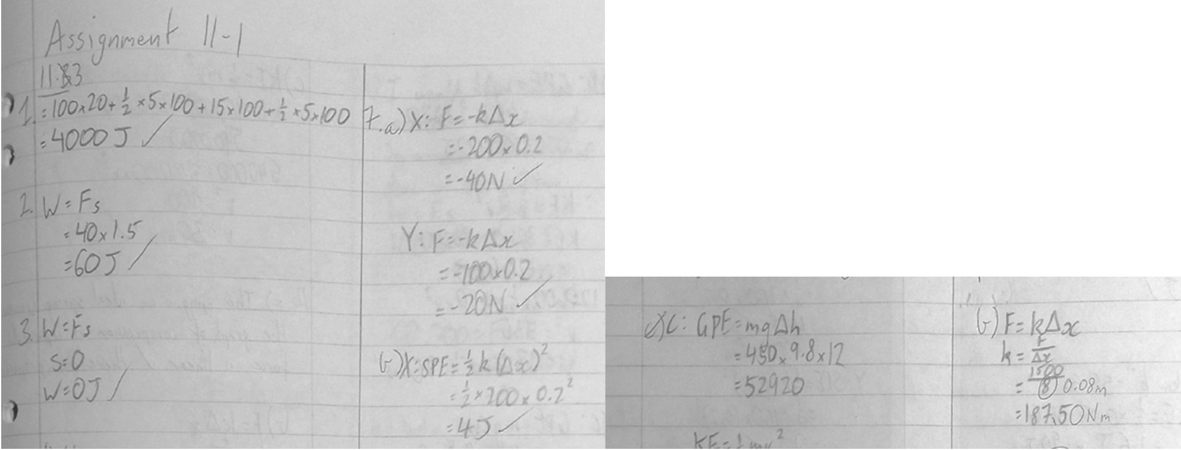

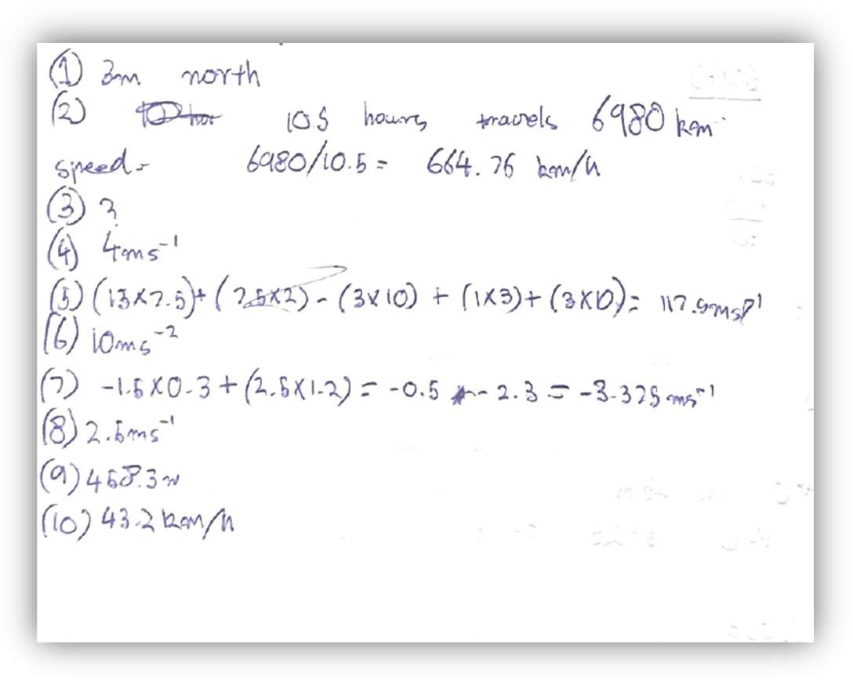**Poor Example** – not corrected, minimal working. No headings. Q3 not followed up.

# For all of the following examples, show ALL of your working.

Example: A 9.0 V battery operates at 2.6 A. Determine the resistance of the load it is connected to.

𝑉 = 𝐼𝑅 (state the Physics formula you are going to use)

𝑉

𝑅 = 

𝐼

= 9.0

2.6

(substitute values from the question)

= 3.5 Ω (calculate the answer and provide a unit)

# Units & Formulae that you may need:

|  |  |
| --- | --- |
| Current: *I,* measured in Amperes *(*A*)* Charge: *q*, measured in Coulombs (C) Time: t, measured in seconds (s) | 𝑞  𝐼 =  𝑡 |
| Voltage: *V,* measured in Volts *(V*) Energy: *E,* measured in Joules (J) Charge: (*q)*, measured in Coulombs (C) | 𝐸  𝑉 =  𝑞 |
| Voltage or “potential difference” or “voltage drop” | 𝑉 = 𝐼𝑅 |
| Resistance: *R*, measured in Ohms (Ω) | 𝑉  𝑅 =  𝐼 |
| Power: *P*, measured in Watts (W) | 𝑃 = 𝑉𝐼 = 𝐼2𝑅, 𝑃 = E  t |
| Energy: *E,* measured in Joules (J) | 𝐸 = 𝑃𝑡 , 𝐸 = 𝑉𝐼𝑡 |
| Resistance in series | 𝑅T = 𝑅1 + 𝑅2 + 𝑅3 … |
| Resistance in parallel | 1 1 1 1  = + + …  𝑅T 𝑅1 𝑅2 𝑅3 |

**Electric circuits – show all working in your exercise book.**

1. 450 C of charges passes a point in 30 sec. Determine the current in Amps.



1. Determine the total amount of charge passing through a globe if it runs at 0.3 mA for 40 sec.



1. Determine the total time (in sec) for 1.2 C to be delivered at a rate of 300 mA.



1. Determine the voltage across a component if 1500 J is carried by 75 C of charge.

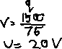

1. Determine the total energy delivered by 0.3 C with a 9.6 V supply.



1. Determine the resistance of the filament in a commonly used light globe, if the current is 0.25 A when the potential difference is 240 V.

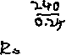

1. Calculate the current in a 1.2 kΩ carbon resistor connected across a potential difference of 6.0 V?



1. What is the voltage across a 48 Ω heating element when there is a 5.0 A current?



1. The heating element of an electric toaster carries a current of 5.0 A when the potential difference across it is 240 V.
2. How many coulombs of charge move through the heating element in 60 seconds? (Hint: Consider current)



1. How much energy does *each* of these coulombs of charge use while moving through the heating element? (Hint: Consider voltage)



1. What is the power rating marked on the toaster (in Watts)? This is the rate at which it transforms electrical energy into heat and light energy.

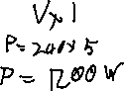

1. How much energy is therefore used up in the heating element in 60 seconds? Answer in kJ.



1. An electric jug is marked “230 V 1.7 kW”.
2. When in normal use, what is the current in its heating element?



1. How much electrical energy does it transform into heat energy if it takes 2 min 21 s to boil some water? (Hint: convert to seconds, use Energy formula)



1. Two electric light bulbs **X** and **Y** are marked “230 V 100 W and “230 V 40 W” respectively.
2. Determine which bulb has the higher resistance.

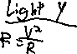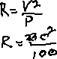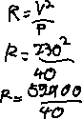

1. How much electrical energy (in kJ) is used if **X** is left on for 5.0 min? (Hint: convert to seconds).



1. Determine the total effective resistance if three 15 Ω resistors are connected in parallel.



1. Key algebra skills:
2. 𝑉 = R2 * 𝑉 . 𝑉 = 6.0 V , 𝑉 = 1.5 V , 𝑅 = 120 Ω . **Solve for** 𝑹

out

Rl+R2

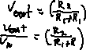

in in

out 1 𝟐

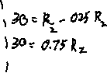

1. 𝑉 = R2 * 𝑉 . 𝑉 = 9.0 V , 𝑉 = 3.0 V , 𝑅 = 60 Ω . **Solve for** 𝑹

out

Rl+R2



in in

out 2 𝟏



1. 𝑃 = 𝐼2𝑅. 𝑃 = 150 W, R = 90 Ω. **Solve for *I.***



1. sin 𝜃 = 0.2. **Solve for** 𝛉**.**



1. Pl = Tl4. 𝑃 = 350, 𝑃 = 800, 𝑇 = 150. **Solve for** 𝑻

P2 T24 1 2 2 𝟏



# SECTION 3 – Understanding language of questions

Take a moment to read and digest the table of terms below. This is a very important aspect of Physics to practise, especially if English is not your first language.

|  |  |  |
| --- | --- | --- |
| **Verb** | **Definition** | **Meaning** |
| **Analyse** | Use qualitative and quantitative methods to identify and distinguish between the elements and constituent parts of the whole, and explain the relationships between them; recognise patterns. | Consider presented information and clarify concepts and knowledge; use qualitative and quantitative methods to distinguish between components (words, tables, labelled diagrams, calculations, graphs); recognise patterns; identify and relate implications; undertake a graphical analysis of data |
| **Apply** | Use knowledge, ideas, formulas, principles, theories, laws, models and/or techniques in a new situation or context; propose a solution or response to a problem or issue. | Propose a solution or response to a problem or issue; show steps; use algebraic and/or graphical methods as appropriate and according to established rules. |
| **Calculate** | Use mathematical formulas and modelling to solve quantitative problems. | Solve numerical problems by using formulas and mathematical processes; find the numerical value of an unknown variable or constant. |
| **Compare** | Identify and list the similarities and differences between two or more objects, situations, concepts or processes. | List, tabulate or use a graphic organiser to identify similarities and differences. |
| **Convert** | Express quantities in alternative units of measure. | Change a unit of measure of a specific quantity to another unit of measure. |
| **Describe** | Communicate the characteristics and features of an event, object, procedure, concept or process using written, oral or visual representations. | Use written, oral or visual representations to communicate characteristics or features. |
| **Design** | Create a plan, object, model, system, simulation or set of procedures to suit a particular purpose. | Combine knowledge, skills, materials and processes to develop a solution to a problem. |
| **Evaluate** | Make reasoned judgments or decisions on given or collected information, based on established criteria. | Assess the merit (strengths and limitations)of ideas, processes or procedures and reach a conclusion; validate evidence; choose from options based on reasoned arguments. |
| **Explain** | Make clear; account for the reason for something or the relationship between cause and effect; state why and/or how. | Provide reasons, mechanisms and outcomes, incorporate quantitative data as appropriate. |
| **Identify** | Recognise and name particular elements of a whole or part; select from a number of possibilities; select relevant information or aspects of key ideas. | Recognise and name/label a specific object, element, component or underlying principle or concept; label/annotate components of a system, model or diagram. |
| **Interpret** | Construct conceptual meaning from information provided in a variety of forms. | Derive meaning from information presented in multi-modal texts (for example, written, aural and diagrammatic), tables, images and graphical formats. |
| **Investigate** | Undertake practical experiments and research to find out the answer to a question or problem. | Conduct experiments and research to find out the answer to a question or problem. |
| **Model** | Use a familiar and known concept or construct to facilitate the understanding of a new and more complex concept or construct. | Show the structure or operation of an object, concept, system or process by using a description, pattern, plan or two- or three- dimensional representation. |
| **Select** | Choose from a number of components, options or processes. | Decide which electronic components should be used to construct a circuit for a specific function. |

**Answers – make sure you check your solutions and correct/annotate any that you are unsure of.**

**Section 1 – Units and standard form. 1.**

**Section 2 – Calculations. Answers only – you need to show full working!**

1. 𝐼 = 15 A
2. 𝑞 = 0.012 C
3. 𝑡 = 4.0 sec
4. 𝑉 = 20 V

|  |  |
| --- | --- |
| **General Form** | **Standard Form** |
| 1079 | 1.079 * 103 |
| 275000 | 2.75 * 105 |
| 0.0000113 | 1.13 * 10-5 |
| 0.03051 | 3.051 * 10-2 |
| 1,300,657 | 1.300657 * 106 |

𝐸 = 2.88 J

9. 𝑅 = 960 

**2.** 10. 𝐼 = 0.005 A or 𝐼 = 5 mA

11. 𝑉 = 240 V

|  |  |  |
| --- | --- | --- |
| **General Form** | **Significant Figures** | **Standard Form** |
| 6578 | 2 | 6.6 * 103 |
| 0.00213 | 1 | 2 * 10-3 |
| 1.4567 * 104 | 3 | 1.46 * 104 |
| 0.00000299 | 2 | 3.0 * 10-6 |
| 2976899 | 4 | 2.977 * 106 |

12a. 𝑞 = 300 C

12b. 𝐸 = 240 J

12c. 𝑃 = 1200 W

12d. 𝐸 = 72 kJ

13a. 𝐼 = 7.4 A

13b. 𝐸 = 239.7 kJ

# 3.

14a. 𝑅y = 1323 

|  |  |
| --- | --- |
| Prefix units | SI Units |
| 450 kV | 4.5 * 105 V |
| 3.5 MW | 3.5 * 106 W |
| 700 mA | 7.0 * 10-1 A |
| 7.9 GJ | 7.9 * 109 J |
| 900 𝜇A | 9.0 * 10-4A |
| 45 pm | 4.5 * 10-11 m |
| 650 nm | 6.5 * 10-7 m |
| 2.47 * 103 kV | 2.47 * 106 V |
| 1.50 * 102 nm | 1.5 * 10-7 m |
| 7.45 * 102 THz | 7.45 * 1014 Hz |
| 9.8 * 102 MΩ | 9.8 * 108Ω |
| 0.685 μC | 6.85 * 10-7 C |

14b. 𝐸 = 30,000 J = 30 kJ

15. 𝑅 = 5 

16a. 𝑅2 = 40 

16b. 𝑅1 = 120 

16c. 𝐼 = 1.29 A

16d. 𝜃 = 11.5o

16e. 𝑇1 = 122o